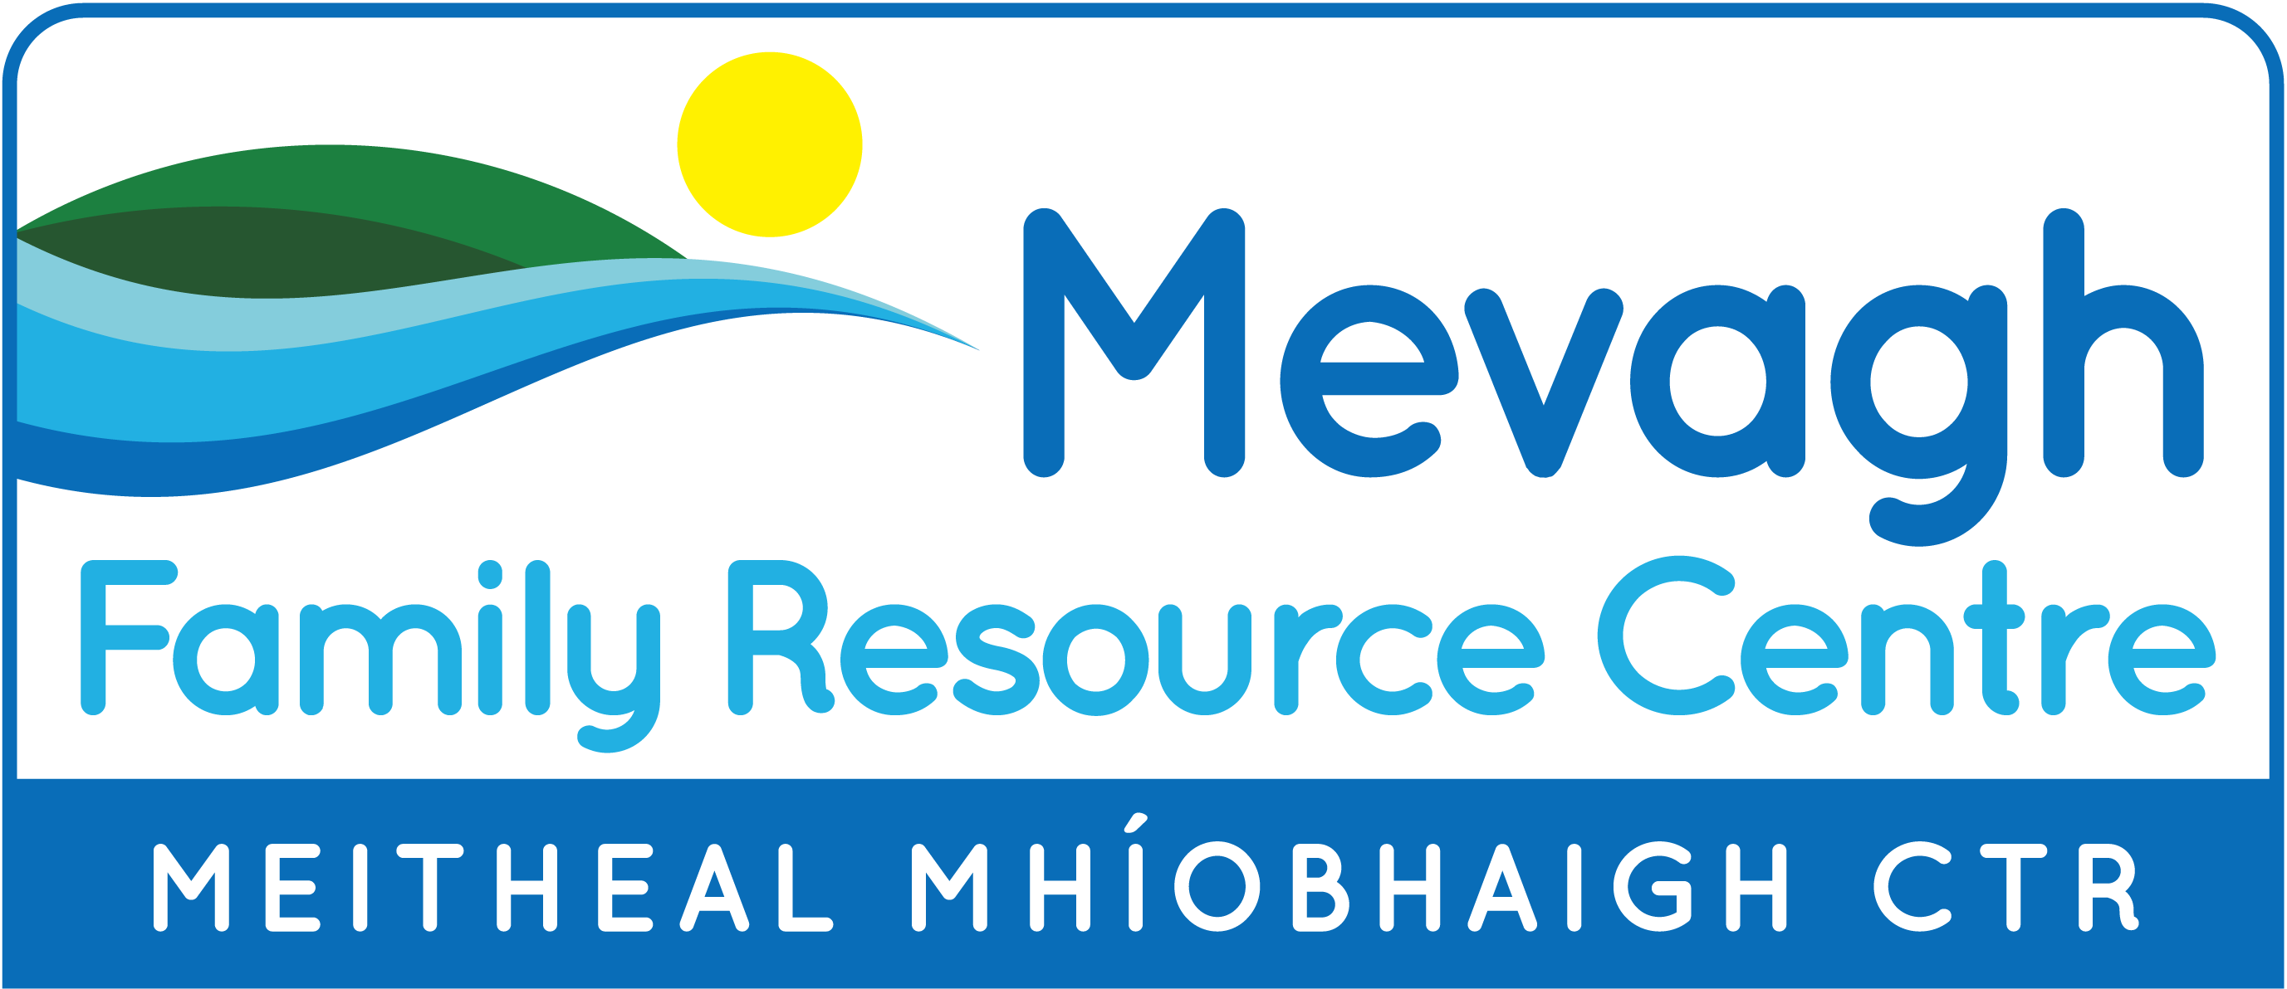

Áras Ros Goill, Downings
Call: 074 9155055 or text 087 9228944 Email: info@mevaghfrc.com.
Check out our Facebook Page – Mevagh FRC or Website – www.mevaghfrc.com

Citizens Information Drop Inn Clinic will be held in the centre on Wednesday 17 July from 10am – 12pm. No appointment is necessary.

Breast & Bottle-Feeding Support Group - This group, for Mum’s and new babies, and facilitated by the Public Health Nurse runs on the 1st and 3rd Wednesday of each month. The next meeting will take place on Wednesday 17th July from 11am to 12:30pm in Mevagh FRC. Call in for a cuppa and a chat. No booking necessary. Tel: 074 9155055 (FRC) or Tel: 074 9155430 (PHN).
Busy Bees, Parent, Baby and Toddler Group for babies to 5-year olds – meet every Friday morning from 10.00am to 12.00 noon. Why not bring your little tots along for a morning of fun? Cost €3 per family.
Mevagh Gardening Group – a few plots are available at our Community Garden at Magherabeg, Downings. Consists of one bed inside polytunnel & one raised bed outside. Reasonable annual fee applies. If interested in joining our group please contact Pauline at Centre.

Men’s Group – will meet at Mevagh FRC on Thursday 18th July at 7pm. Come along for tea, chat and craic.
Senior Alert Scheme – Mevagh FRC continue to assist individuals who require a personal monitored alarm. This alarm is for people aged 65+, of limited means. It enables older people to live securely and independently in their homes. The installation and equipment are free and if you connect to a landline, the monitoring is free for the first year. Charges apply to alarms set up via sim card. This initiative is part funded by Pobal. Please call in, or contact the centre for more information.

TÚS Community Employment Scheme (19½ hrs) Administrative Assistant - A vacancy exists at Mevagh FRC for an Administrative Assistant. Experience an advantage. Candidates must be in receipt of Jobseekers Allowance for at least one year. To confirm eligibility or for further details, contact Áine Uí Rabhartaigh on 087 2366912 or email a.uirabhartaigh@udaras.ie

Other Notes:

Coffee Morning – Holy Trinity Church, Carrigart will host a Coffee Morning on Wednesday, 17th July at 11:00 am in the Hay Hall, Carrigart. All Welcome.
Paint Me Glaze Me Pottery Studio – held in Mevagh FRC, Monday to Friday @ 11am – 3pm, throughout July & August. Paint your own pottery and t-shirts. Choose from a selection of pre-made ceramic figures, mugs and t-shirts to paint in your own unique way. Facebook: ‘Paint me Glaze me Pottery Studio Downings’. Tel: 00 44 7866510852. Walk in or book for parties of four or more.

ALONE provides services to Older People to enable them to stay living at home for longer. Volunteers are needed in Downings and surrounding areas for two services: ‘Visitation & Befriending Service’ and ‘Telephone Support & Befriending Service’. If you would like more info. Contact Helena on 086 014 5829.

Rise Yoga with Fiona is ongoing at Mevagh FRC. Chair Yoga - Mondays at 10.30am, Yin Yoga – Mondays at 11:45am. Contact Fiona directly to book your place. Tel: 0851569424 or Email: risehealthhub@gmail.com

Yoga Kindly with Brigitte continues on a Saturday morning at 9:45am in the Resource Centre. Contact Brigitte on 087 0653333 for more information.

